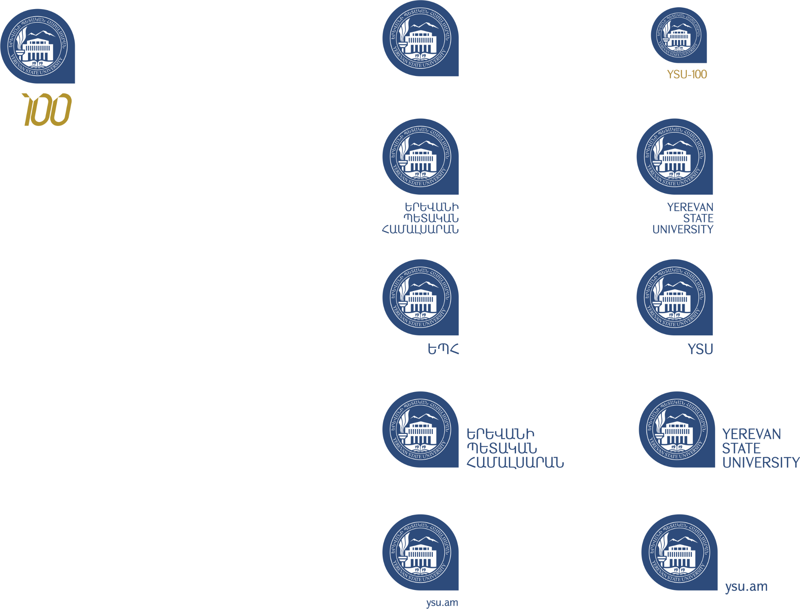

**ԹԵԶԻՍԻ ՁԵՎԱՎՈՐՄԱՆ ՕՐԻՆԱԿ**

**THE ADAPTATION OF THE ARMENIAN VERSION OF THE STUDENT'S PSYCHOLOGICAL WELL-BEING SCALE**

The study was carried out with the financial support of «Project….»

*John Smith (University of Oxford, Oxford, England)*

[*smith@gmail.com*](mailto:smith@gmail.com)

Short abstract text (max 100 words).

Keywords: 5-10 words.

The main text (max 5 pages).

**References**

1. …
2. …
3. …
4. ․․․
5. ․․․